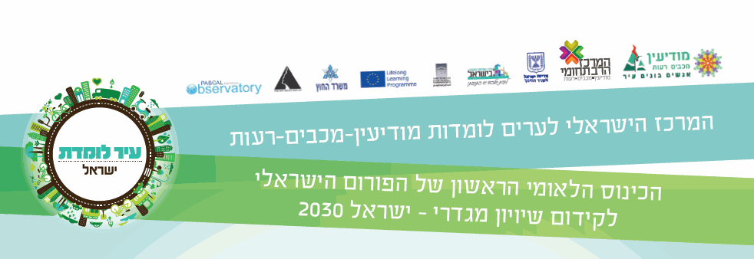**Declaration**

We, members of the Israeli Forum for Gender Equality and Empowerment of Women, and Girls for social inclusion Israel 2030, the Minister for Social Equality, the Mayor of Modi'in-Maccabim-Reut and Chairman of the Federation of Local Authorities in Israel, Secretary General of UNESCO Israel, a senior director of PASCAL international, have gathered in Modi'in, the Israeli Center for Learning cities, on March 2nd, 2016, to continue to promote gender equality within the public agenda, to promote dialogue, relationships and partnerships in Israel and worldwide, to promote our action and impact, together and individually, in order to recruit all sectors and policy makers to work towards achieving the goals of the United Nations in 2030.

"Achieving gender equality and empowering all women and girls" is defined as a major goal by the 2015 UN Convention, one of 17 sustainable development objectives (SDGS) that will shape our society during the next fifteen years.

The Forum expresses its full support for the UN Convention SDG S goals, in particular goal SDG 5 that aims to promote gender equality.

Ensuring equal opportunities for women and girls, lifelong learning, personal development, employability and active participation in society and in decision-making centers, is a necessary condition for social resilience. We will act together, as a national Forum, for the implementation of these goals in favor of an equal and inclusive society in Israel in 2030.

**Call for Action**

The Forum is committed to act in the spirit of the 2015 UN Convention goals and objectives to promote gender equality and to implement gender thinking, and to promote the 12.2.2014 government decision to prepare a national plan for the subject. This commitment is a common social interest, sustainable and beneficial to both men and women, forming an equal and progressive society.

The Forum calls on all decision makers in the various sectors to lead groundbreaking solutions and a fundamental change. High commitment and personal responsibility of government policy makers and local authorities, cities and organizations is essential for the creation of a new gender schema.

We must all act to amplify the dialogue on equality and critical thought within all levels of the population, the various sectors, organizations and institutions, and to deepen the commitment for action, realizing that awareness and active work are the key to the promotion of equal representation in the public sphere, supportive legislation, budget allocation, gap reduction and achieving the UN goals towards 2030.

**טו**